FileZilla Download Instructions

Go to the web site: http://filezilla-project.org/download.php?type=client
Select either Windows or Mac or Linux operating system, based on your computer
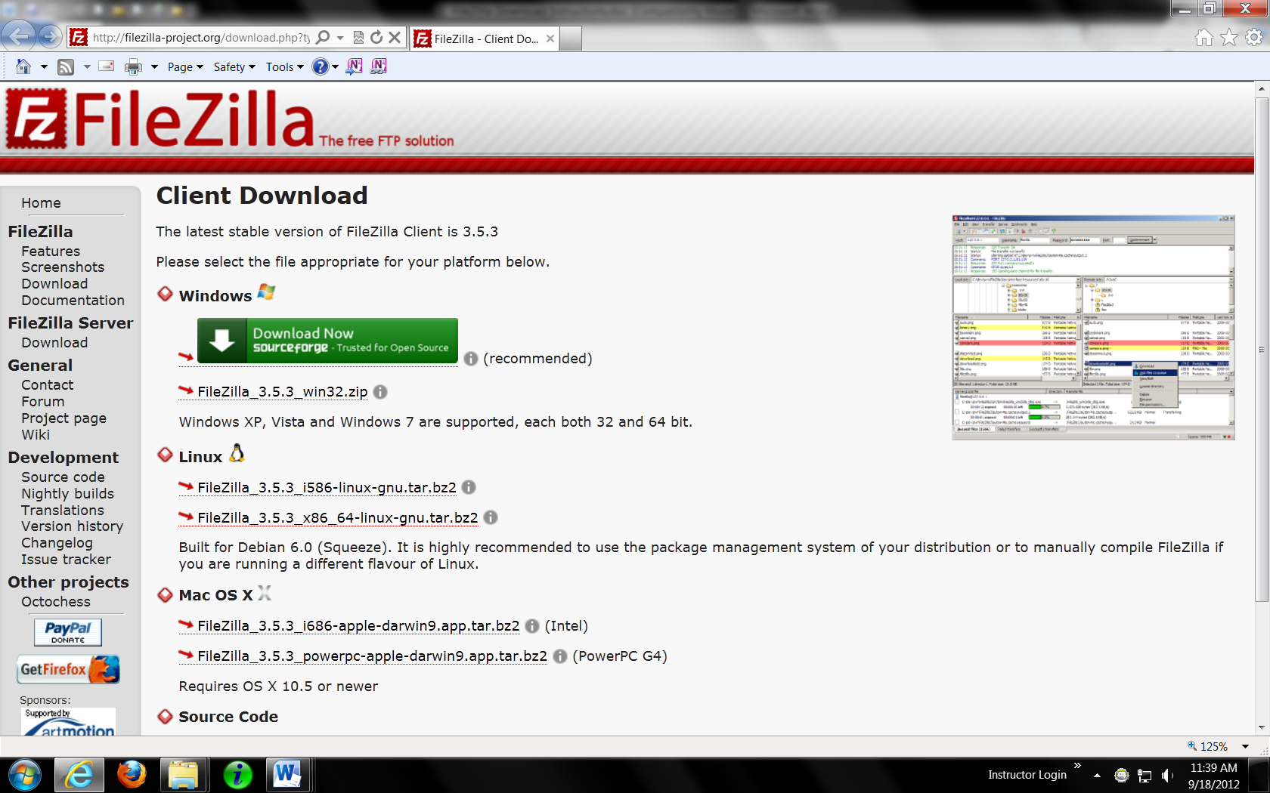

This message displays; Select “Run”
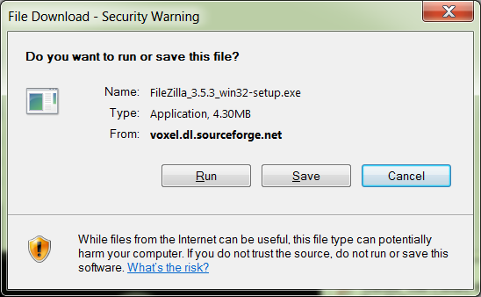
Click “Run” on this Security Warning
